**5 Sept 2014** **The Weekly Bulletin of Rotary Club of Kathmandu Mid-Town** **bc-10/9.014**

|  |
| --- |
|  |

District: 3292 Web:www.rotarymidtown.org.np Club Id: 26776

**SEPTEMBER IS NEW GENERATIONS MONTH**

**Celebrating**

**25 Years in Rotary**





Friday, 29 August : Extracts of the Minutes # 1244

“Induction of Members:

PP Mani & VP Peter carried out the induction while AG Rajenda provided Rotary Booklets to the following Members:

Mr. James Larry Kelly, Ms. Sangita Shrestha, Mr. Sanjib Raj Bhandari, Dr. Shankar Sharma, Ms. Sheri Meyerhoffer.”

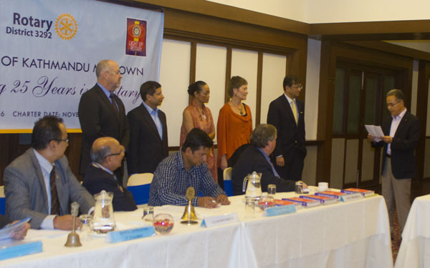

*Above: PP Mani Joshi administering the Induction of five new members to the Club;*

*President Kul, Vice-President Peter, IPP Saroj and Jt Sec Pramod look on.*

*Below: VP Peter Bode providing Rotary pins to incoming members.*

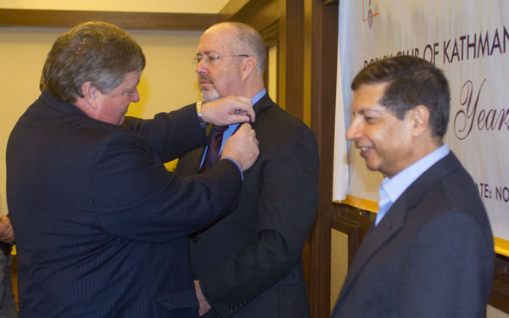

*to Mr James Larry Kelly*

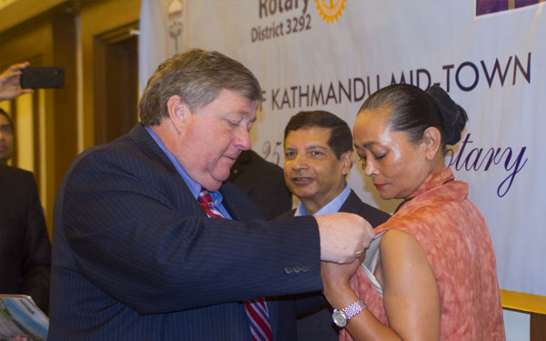

*to Ms Sangita Shrestha Einhaus*

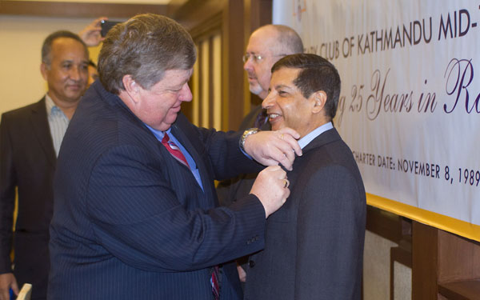

*to Dr Shankar Sharma*

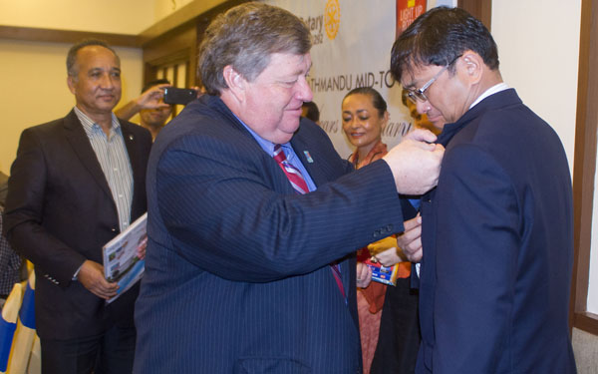

*to Mr Sanjib Raj Bhandari*

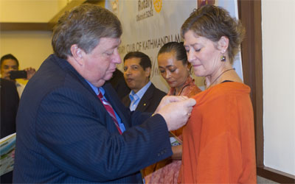

*to Ms Sheri Meyerhoffer*



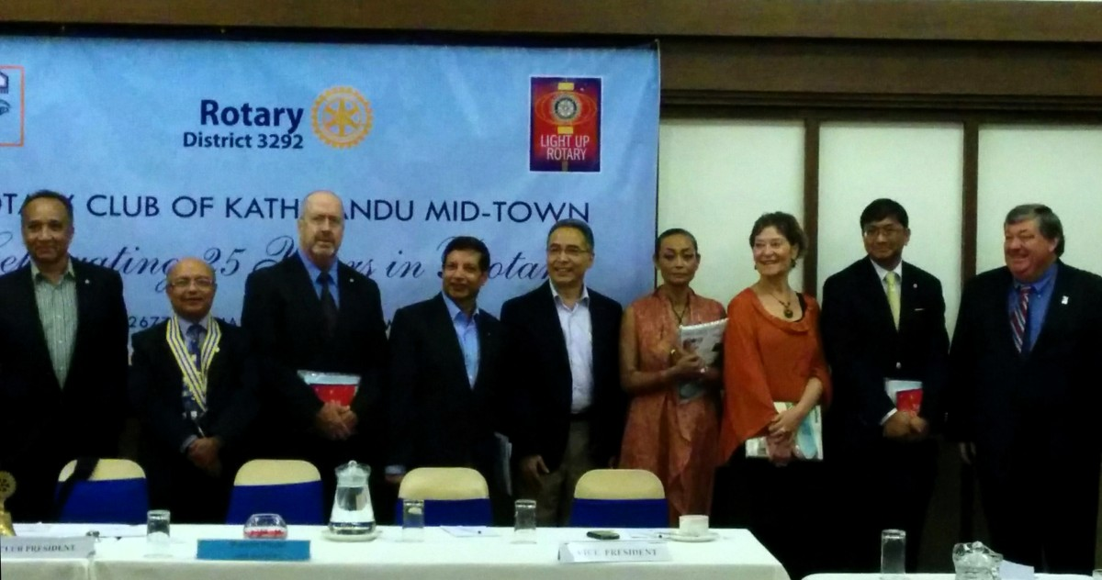

AG Rajendra, President Kul, PP Mani and VP Peter with new Rotarians of the Club

in a photo session after the Induction ceremony was over.

The five ‘just-inducted’ members of the Club are now the newest Rotarians of Rotary International.

**Congratulations to you all.**

**Welcome to the Club !**

><><><><><><><>

“President Kul then requested AG Rajendra to conduct the Club Assembly.

“AG requested all respective committee chairs to present their report.” (Copies of reports presented by respective chairs are attached to the minutes)

“Speaking on behalf of Membership Chair Rtn Deepak, PP Ajay informed that the Club target of 10 percent membership increment has been met with the induction of five members, but, with the newly set district target, our club requires three new members.”

“No report from Club Administration”

><><><><><><><>

Information Sharing:

- “Dr Ernst Preyer, Chief of Professional fire Brigade and representativoe from President Office of Autonomous Province of Bozen Bolgano expressed his gratitude saying that he is in Nepal for renewal of MOU signed with Kathmandu Metropolitcan Office three years ago with regards to the fire brigade project.

- “Rtn Buddha informed that Bolgano was also involved in helping out with mountain medicines.

- “Worthy nominees sought in the sector of culture & art for Gopal Raj Bhandari Vocational Award worth Rs One Million.

- “IPP Saroj gave token of appreciation to PP Arun for his contribution in brochure printing.

- “President Kul said he will be out of Nepal until Oct 10 and VP Peter will be conducting the Meetings.

- “Members present: 37

# Weekly Meetings and Prorams :

|  |  |  |
| --- | --- | --- |
| Date | Program/Speaker | Program/Topics of Presentation |
| 5 September | Craig Sanders, UNHCR Rep | State of the world refugees |
| 12 September | Dr Bekh Bd Thapa |  |
| 19 September | Pitamber Sharma |  |
| 26 September | CAS Gaurav Shamsher Rana |  |

Friday, 5 September:

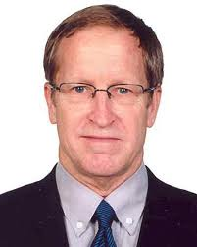

Mr. Steven Craig Sanders, UNHCR Representative, is our Guest Speaker.

Mr. Sanders, an American national, has worked with the UN Refugee Agency since 1992

in a number of countries including Bangladesh, Sudan, Indonesia, Democratic Republic

of Congo, Rwanda, Malawi and at UNHCR Headquarters in Geneva, Switzerland.

Before coming to Nepal, he served as the UNHCR Representative in Bangladesh, Dhaka.

Sanders had also previously served as the UNHCR Dy Representative in Khartoum,

Sudan for 4 years from 2006 to 2010.

He will give a short talk on ‘state of world refugees.’

**Fire Brigade Project, Renewal of the MOU:**

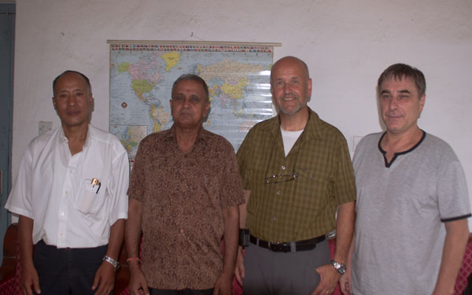

Mr Ernst Preyer, Head, Professional Fire Brigade,

Bozen/Bolzano, Italy, arrived Kathmandu for signing

renewal of the MOU for cooperation for the Fire Brigade

Project signed in 2010 and formalized in March 2011

between our Club, Kathmandu Metropolitan City and

the Autonomous Province of Bozen/Bolzano, Italy.

A meeting was held at KMC, Teku on 28 Aug morning

to discuss core issues of the project.

of the project on 28 Aug.

A group photo was taken after the meeting.

In the photo are (from left to right) :

Mr. Purusotam Shakya (Sr Mech Engineer, KMC), Rtn. Amar Panta (RC-KMT), Mr. Ernst Preyer (Head, Professional Fire Brigade, Bozen/Bolzano) and Rtn. Navyo Eller (Liasion, Province of Bozen/Bolzano).

*Source:* Rtn Navyo Eller

**Congratulations:**

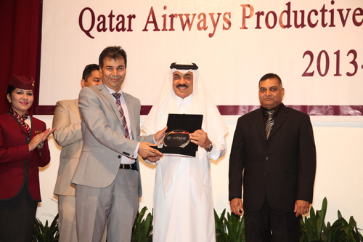

MidTown Rtn Shyam Thapaliya receiving **Platinum**

**Award** 2013-14, one of the top 4 trade partners’ awards,

on behalf of his company Osho World Travel Nepal,

from Qatar Ambassador H.E. Mr. Ahmed Jasem AL Hamar

in *Qatar Airways Agents Award Night* held recently in

Kathmandu. Keep it up**!**

**Gaura Parva:** 3 September

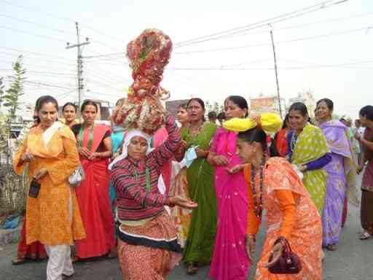

Gaura Parva is the celebration of the divine wedding – Goddess

Gaura (Parvati) and Lord Maheswore (Shiva). People in the

mid and far western regions of Nepal celebrate this festival for

six days beginning on the fifth day and ending on the tenth

day of the bright fortnight or dark fortnight in Bhadra

(August-September) depending on the position of planets at

that time. Women taking the Gaura fasting for the first time

begin with the bright Gaura.

On the fifth day of the bright fortnight in Bhadra, fasting

women perform the ceremony of soaking five different cereals

mixed together called *birudou* in water. They go to the house

where they set up the Chief Gauri called *BudhiGora* and

perform the main ceremony of soaking *birudou* in water.

Then they move on to another house to repeat the same ceremony. They go to all houses in the area one by one to perform the soaking of *birudou* in water. On the seventh day fasting women collect the plant ‘sau’ from the rice field and make idol of Gauri called “Gamara”. On the eighth day, women devotees perform religious rites to Goddess Gauri and God Maheswore at the house of *BudhiGora*. On the ninth day, women bring “Gamara” from their houses and assembly them together to a single *BudhiGora* at the *BudhiGora* house. Devotees perform the wedding of *BudhiGora* and Lord Maheswore. On the tenth day, devotees decorate *BudhiGora* and Maheswore, and then take them to the community courtyard for religious rituals and then to the temple to Pashupati to burn them down. This ends the Gaura Parva.

*Source:* Internet News

**Committee Chairs’ Column:** (This column is for use by chairpersons of 5 permanent committees: Club Administration, Membership, Public Relations, Service Projects, and the Rotary Foundation)

Share any information on club activity plans and programs, reports, progress reviews, or any matter concerning your committee in this column.

All committee chairpersons are requested to send whatever materials relating to the committee activities that can go to Breakfast Chatter to the BC Editor.

*“The vision is really about empowering workers,*

*giving them all the information about what's going on,*

*so they can do a lot more than they've done in the past”*

*-* [*Bill Gates*](http://www.thinkexist.com/english/Author/x/Author_2425_1.htm)

On Lighter Side :





Great Quotes:

**Life consists not in holding good cards**

**but in playing those you hold well.**

***- Josh Billings***

**Members’ Corner:**

This column is for Club members to express anything they would like in matter of Club activities, Club administration, Club issues or on Breakfast Chatter, or on anything else that would be of interest to fellow members.

It is hoped that this column would not go empty!

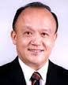

The job of growing membership doesn't end when a new member joins. It ends

only when a new member is enjoying being a Rotarian and never wants to leave!

And making sure that our clubs are enjoyable places to be is a key part of growing membership.

**RI President GARY C.K. HUANG**

Please send information on club activities, progress reviews on service projects, relevant photos etc to:

BC Editor: RR Shrestha email: rryesrr@gmail.com

## 5 September 2014 The Weekly Bulletin of Rotary Club of Kathmandu Mid-Town bc-10/9.014